MySQL

MySQL roadmap and topics from basic to advanced
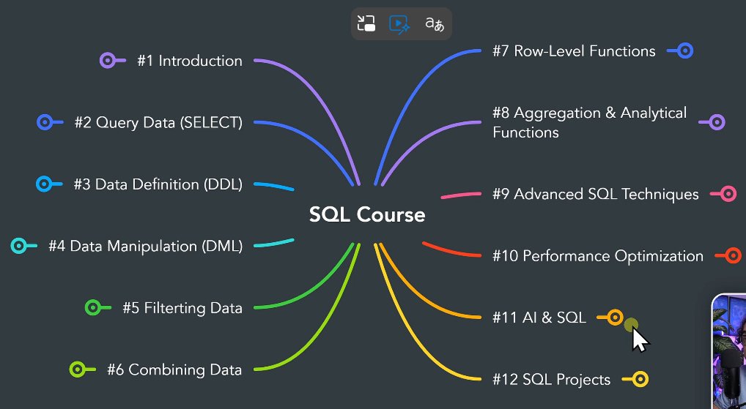

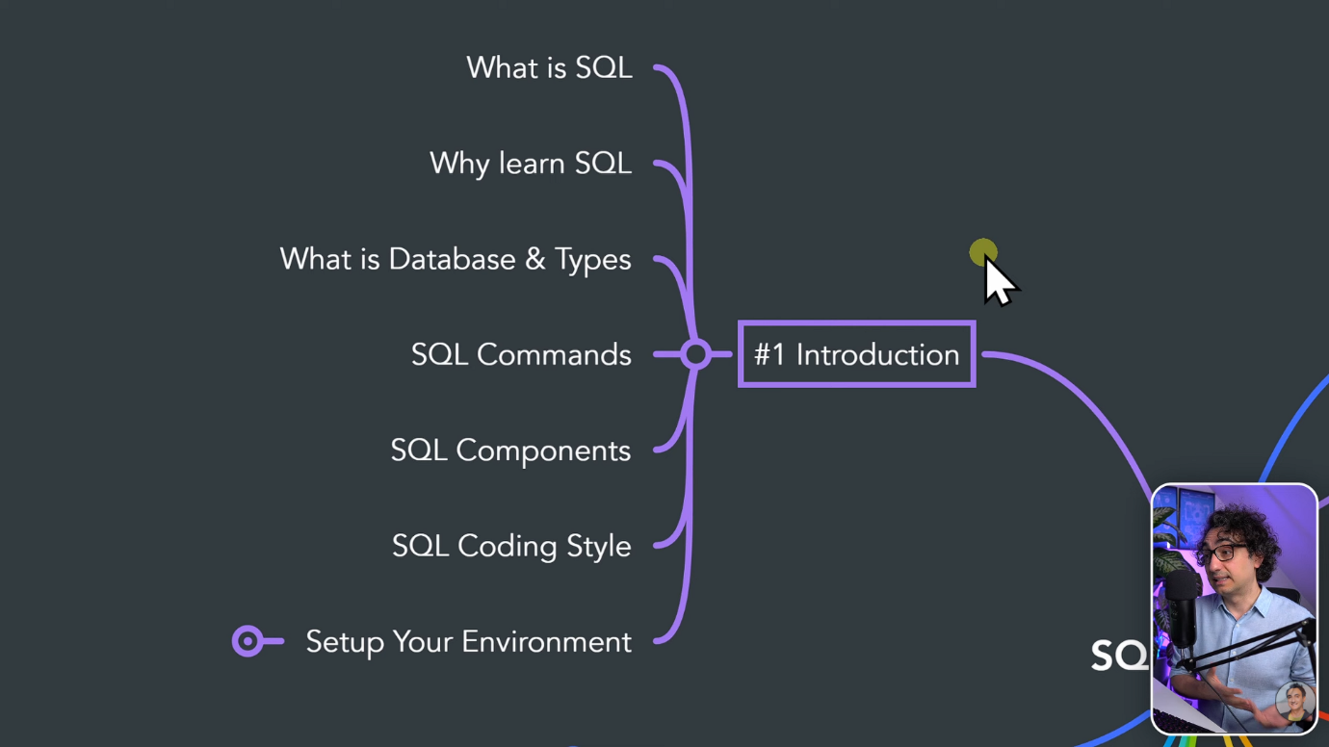
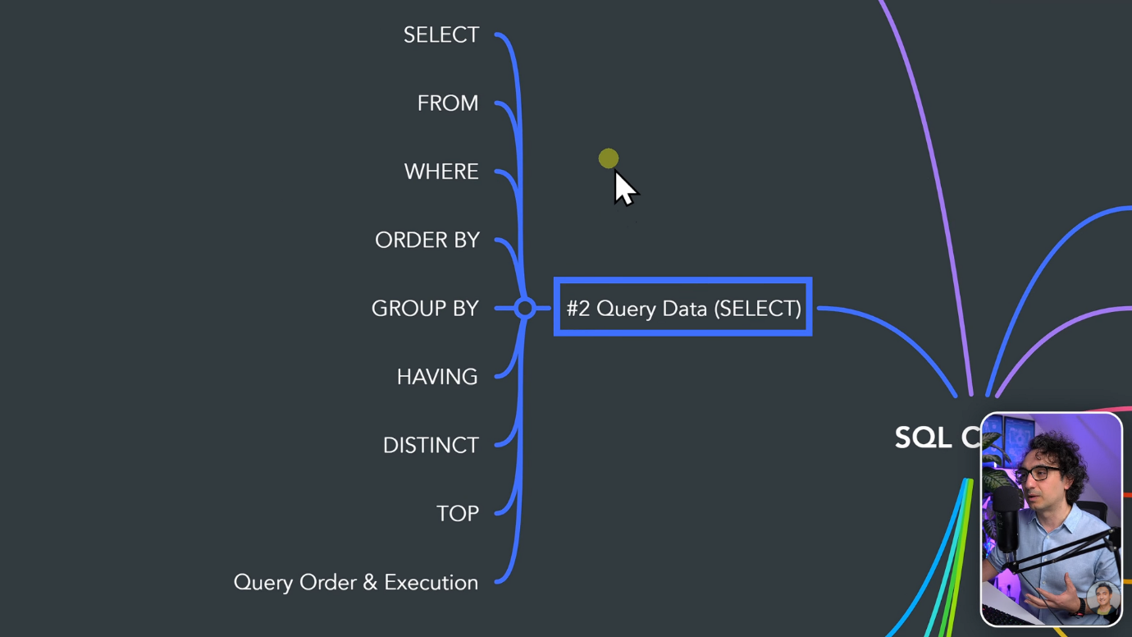

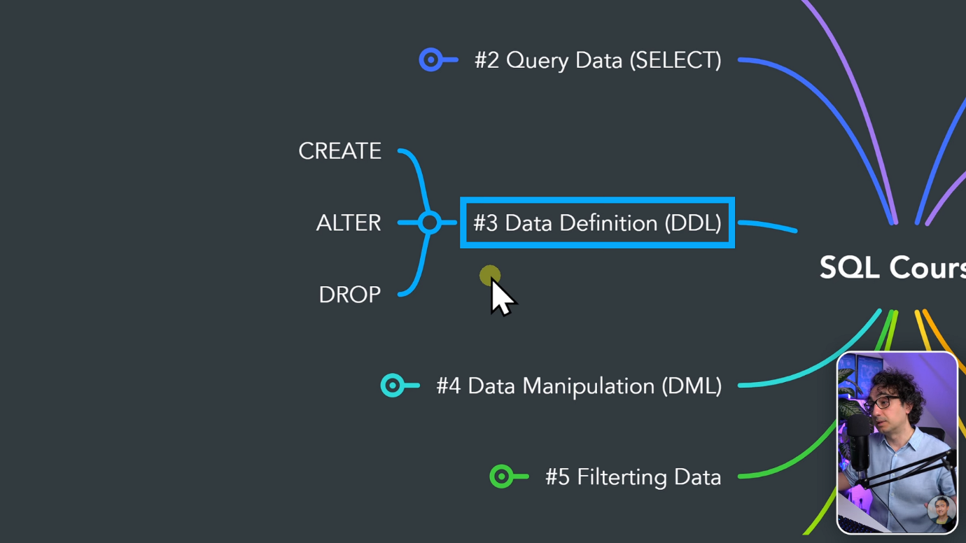

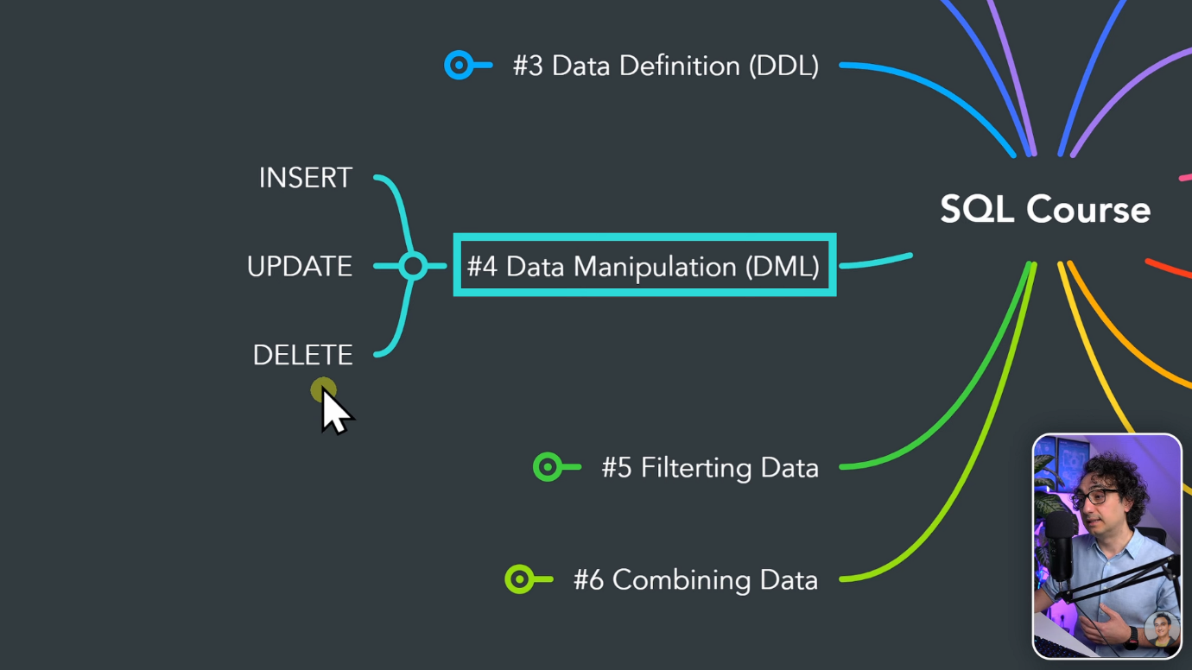

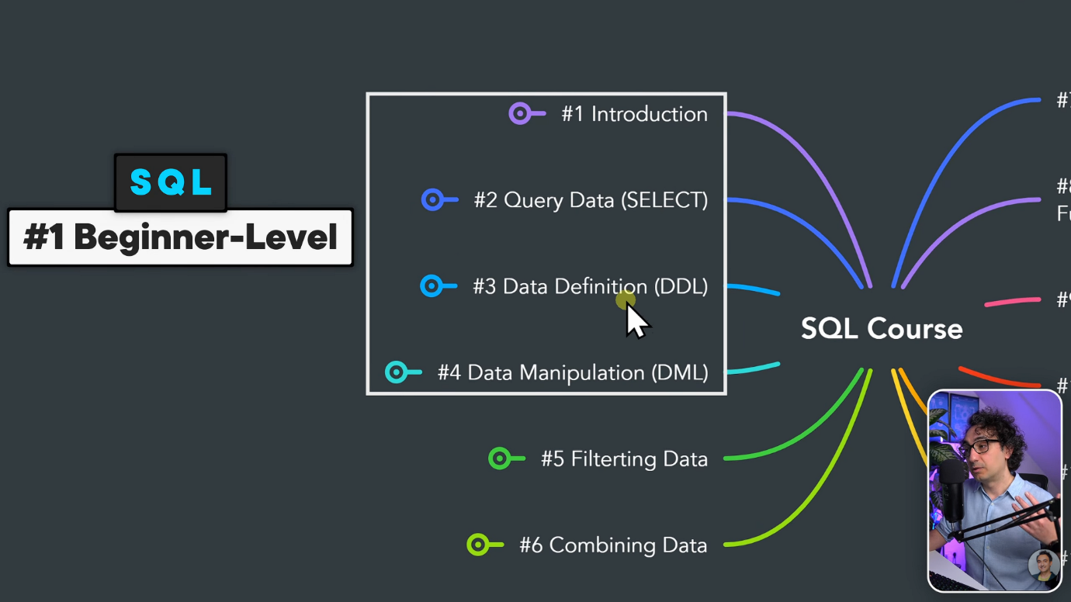

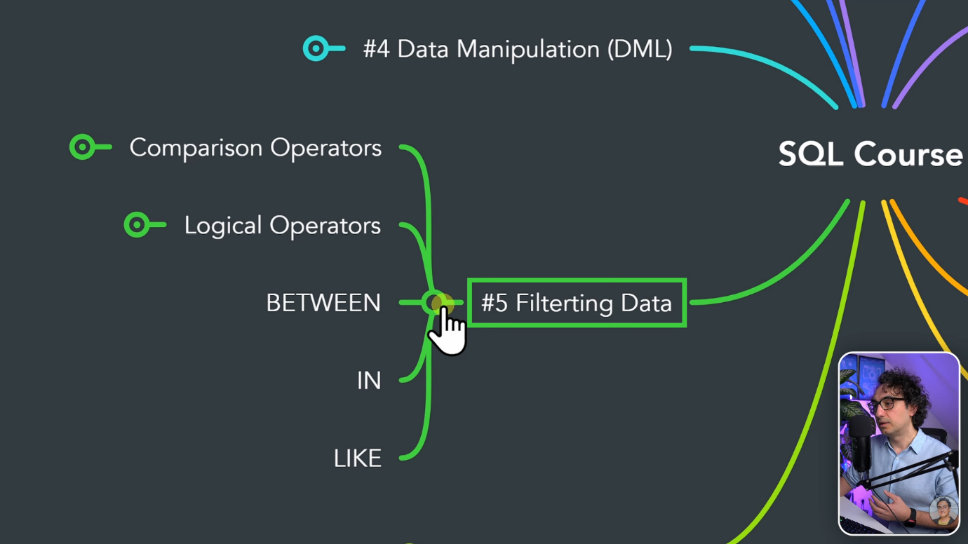

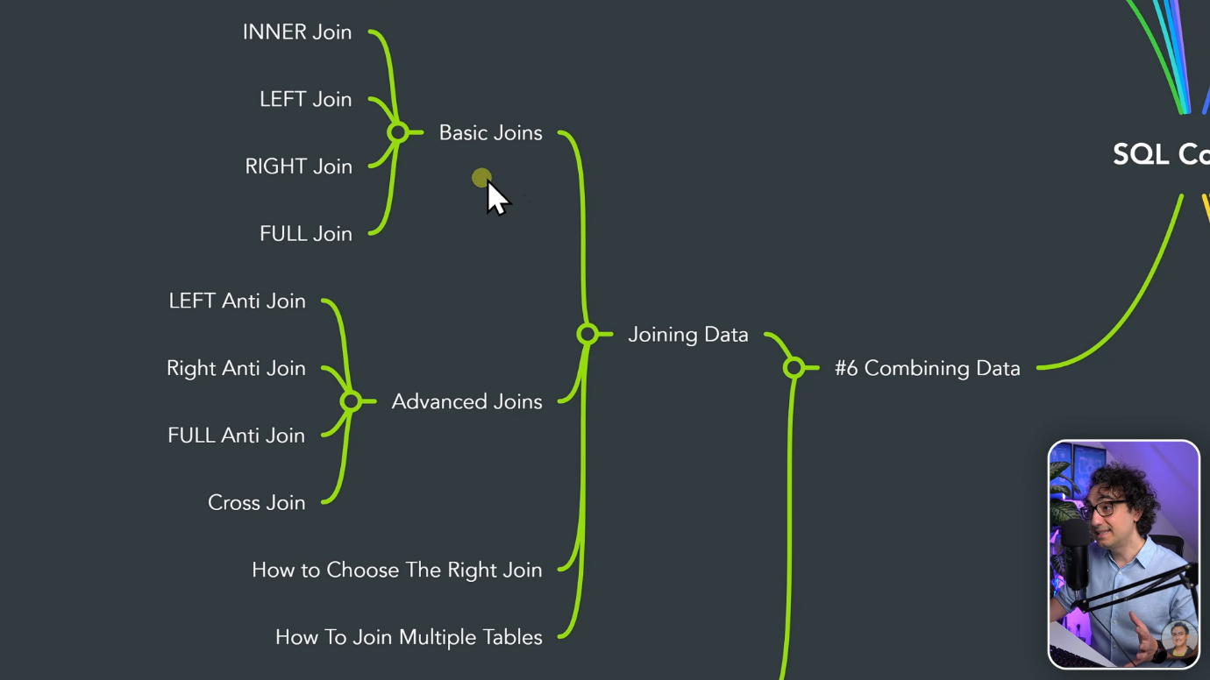

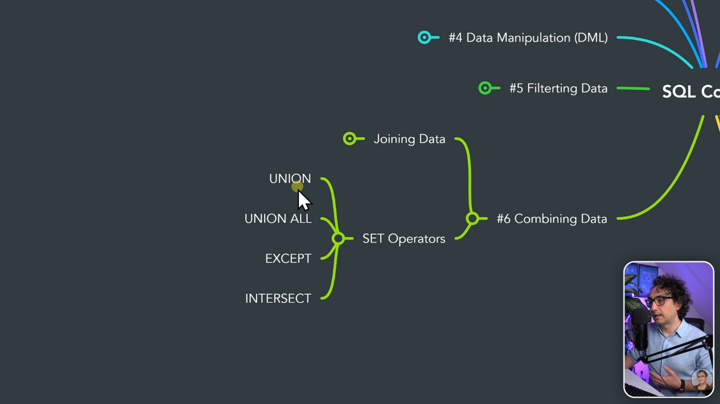

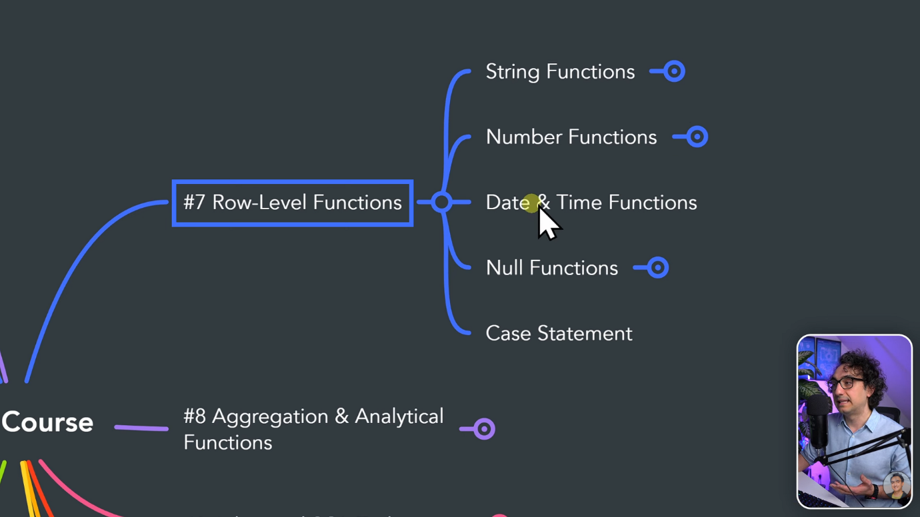

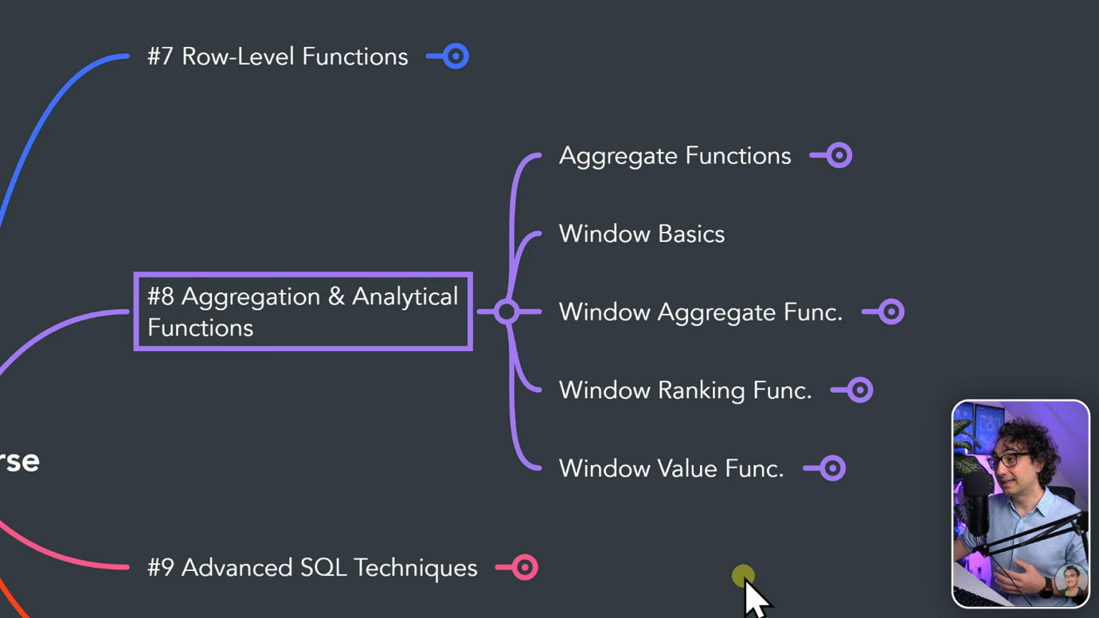

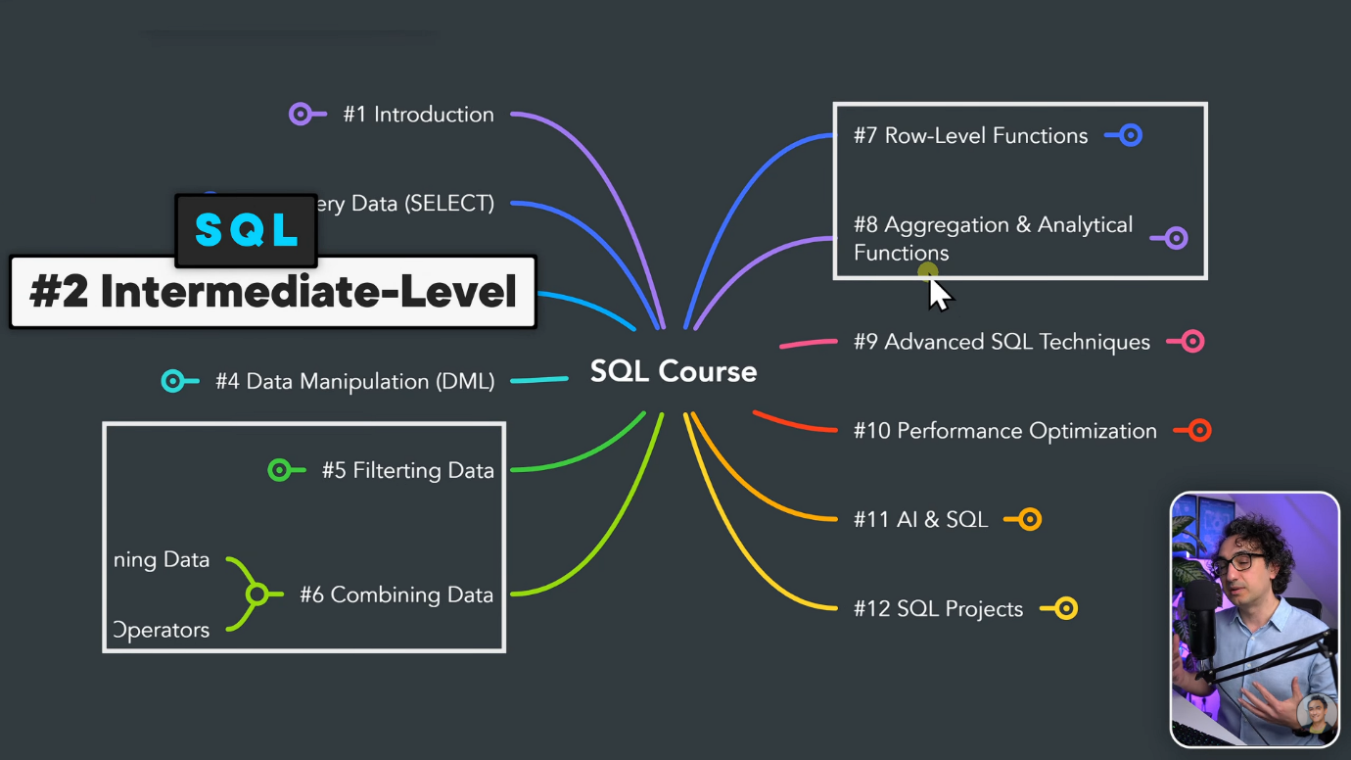

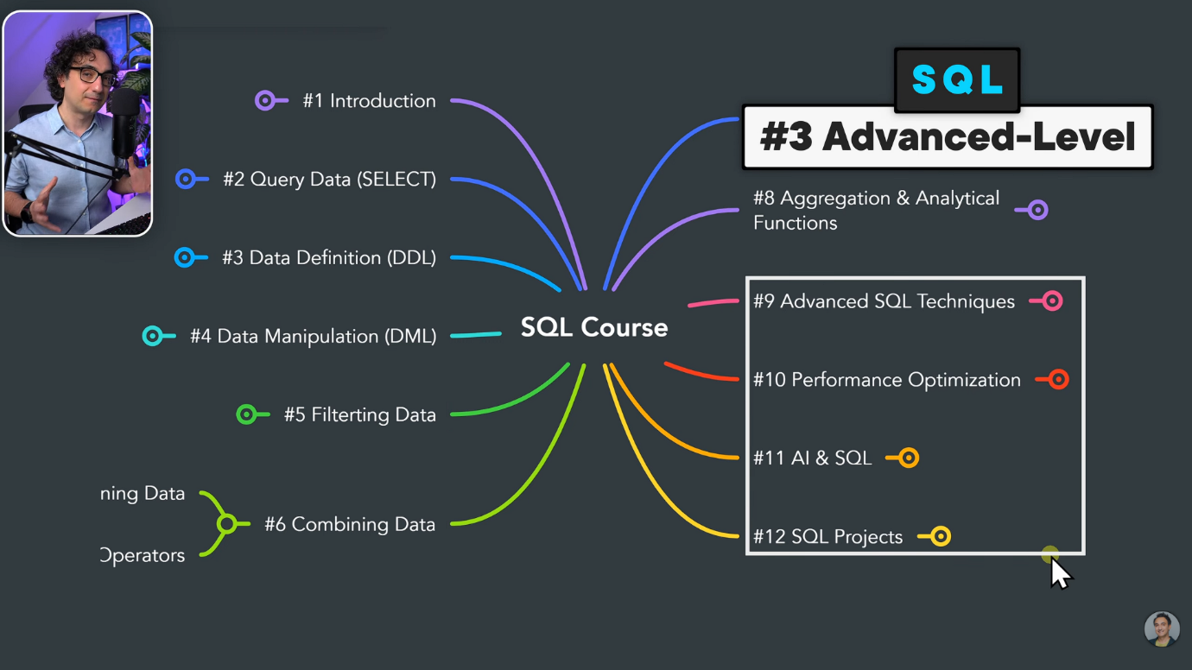

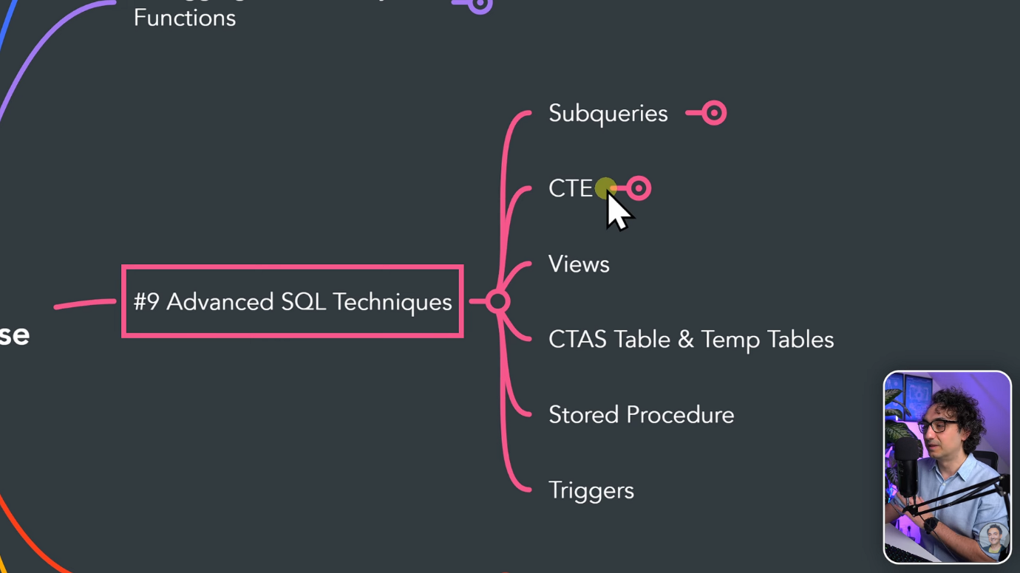

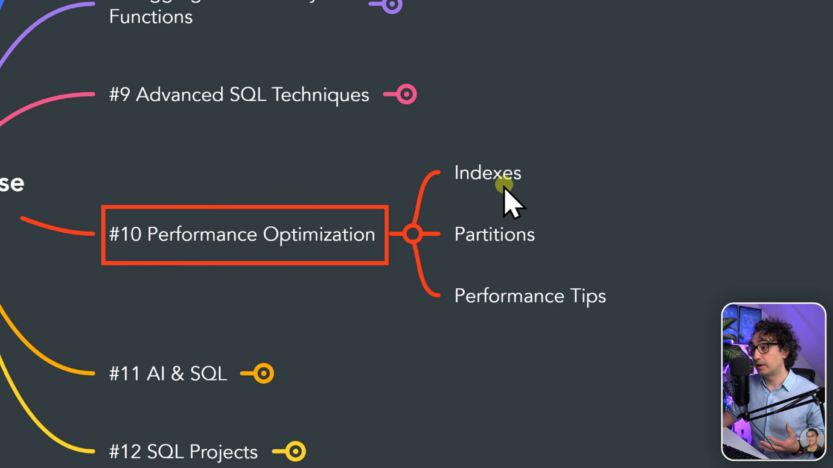

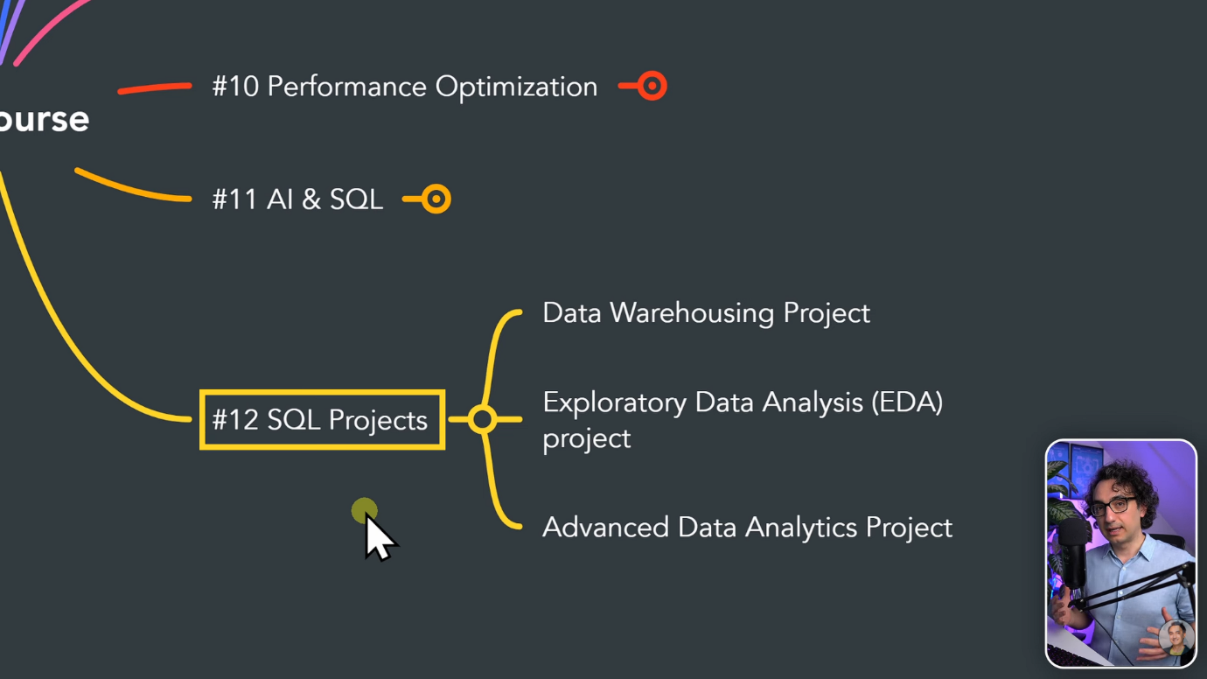

What is data?
A information is called data.

Where do companies store data?
The companies generate a lot of data that is stored in a database.

What is SQL?
SQL is structured query language used to interact with databases to retrieve information or data.

What is database?
A database is a container where we can store information or data.
A database is an organized collection of data that can be easily accessed, managed, and updated.
Think of it like a digital filing cabinet: instead of papers in folders, you have tables of data stored in a structured way.

Why database used for?
Structured storage: Data is stored in tables (rows and columns).
Efficient retrieval: You can quickly search and filter data using queries.
Consistency: Rules (constraints) ensure data is valid and reliable.
Security: Access can be restricted to authorized users.
Scalability: Handles large amounts of data across many users.

What is DBMS?
A DBMS is software that provides an interface between users (or applications) and the database.It ensures data is stored securely, retrieved efficiently, and maintained consistently.
DBMS stands for Database Management System. It’s the software layer that allows you to create, manage, and interact with databases. While a database (DB) is just the organized collection of data, the DBMS is the tool that makes working with that data possible.

Note: Applications and BI Tools (reporting tools) are connecting to DB and producing a large amount of SQL queries. To manage all those things DBMS is used.

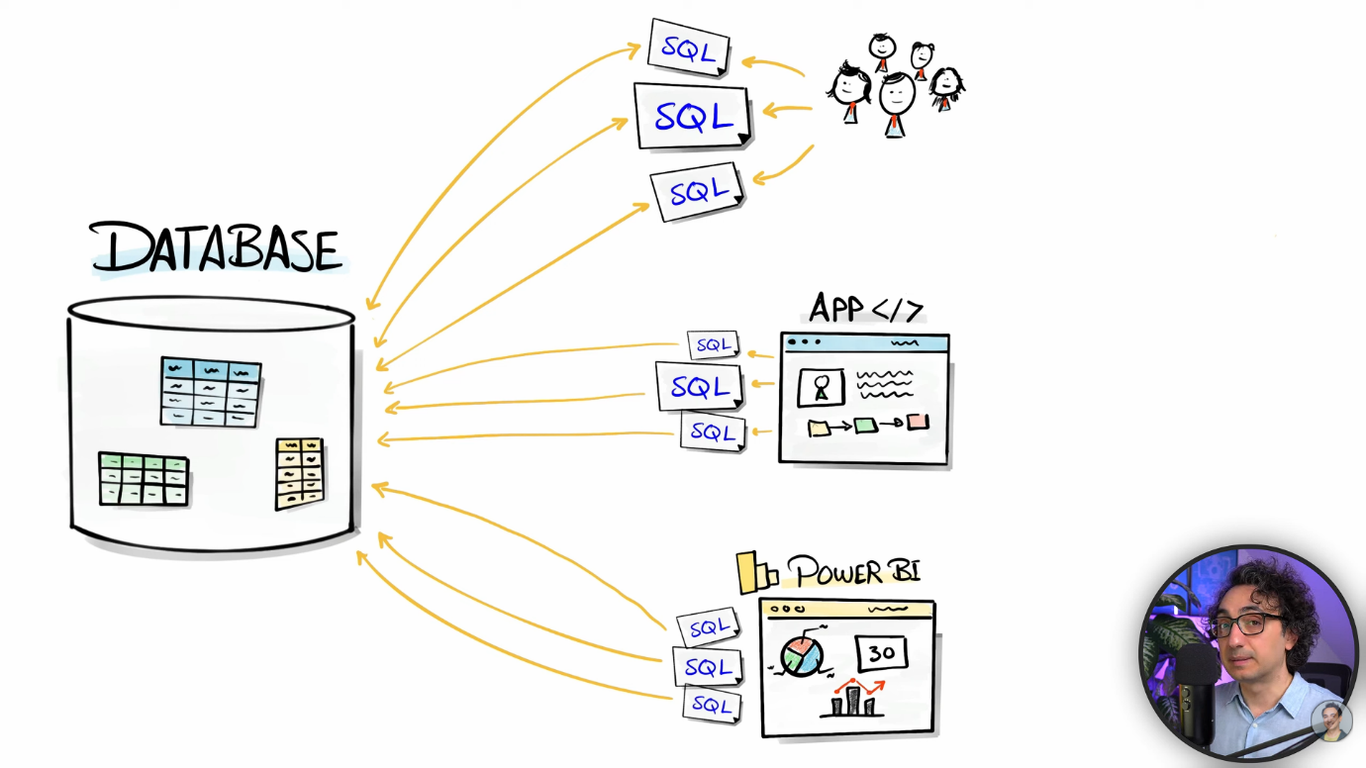

To run DB, we need a server .The DBMS is running on either server which is on Prem or cloud hosted.

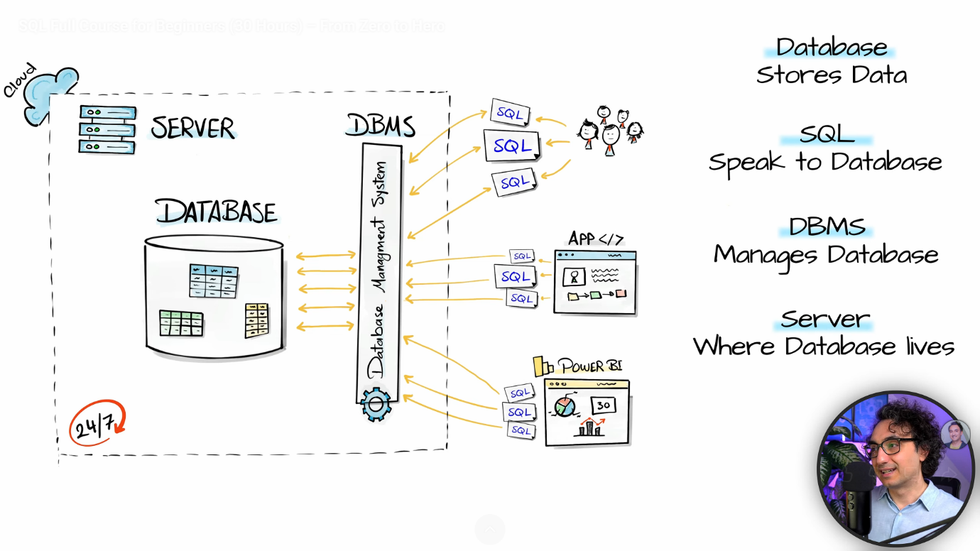

Functions of a DBMS
Data Storage & Retrieval: Stores data in tables, files, or other structures. Allows queries using SQL (Structured Query Language).
Data Manipulation: Insert, update, delete, and retrieve data easily.
Data Security & Integrity: Controls access with authentication and permissions. Enforces rules (constraints) to keep data valid.
Concurrency Control: Manages multiple users accessing the database at the same time without conflicts.
Backup & Recovery: Provides mechanisms to restore data in case of failure.

What is server?
A server is a computer system or software that provides services, resources, or data to other computers, called clients, over a network.

Key Functions of a Server
Data Storage & Access: Stores files, databases, or applications. Provides access when clients request them.

Resource Sharing: Shares printers, storage, or internet connections across multiple users.
Application Hosting: Runs websites, apps, or services (e.g., Gmail, Facebook).
Security & Management: Controls user access, permissions, and protects data.

